**Digitalization of Thermal Energy Technologies –**

**Modelling and Simulation Method**

**Modeling Topic 1 -**

**What is NTP** – Nuclear thermal propulsion technology provides ***high thrust and twice the propellant efficiency of chemical rockets.*** The system works by transferring heat from the reactor to a liquid propellant. That heat converts the liquid into a gas, which expands through a nozzle to provide thrust and propel a spacecraft.

**Why I chose this topic - I am interested in designing small size nuclear powered engines and hoping to continue study this topic in my master’s degree.**

“Also, for human missions to marsthe physical size of an NTP engine is largely determine **by the rate at which the fission energy can be transferred to the hydrogen propellant.” Thus, designing of good heat transfer mechanism will greatly improve efficiency.**

**Questions that needs to be investigated -**

1. How to use the same propellant and use for ***heating of the space shuttle and generating electricity using sterling engine***?
2. What ***different heat exchanger arrangement*** and ***Different compressor types*** can be used?
3. How to design the Nozzle so that ***maximum gas expansion*** can be achieved?
4. ***Different temperature and pressure considerations*** needs to be considered as both of them will change continuously with altitude and will be negligible in space.
5. How does using ***different propellant*** will impact the ***temperature considerations***? Both Nitrogen and Hydrogen have ***different expansion rates*** thus will require different design considerations. Also, both of them have different heat capacity rate.
6. “Surprisingly, designing a reactor to achieve criticality was the least of the problems. Innovative work had to be performed to store and pump liquid hydrogen, and to develop materials capable of withstanding the harsh environments both inside of the reactor core and external to the rocket engine. **The radiation heating in the core and the surrounding structure had to be considered as well as the environment external to the engine. Everything inside of the core and surrounding structure had to be cooled, and heating was inconsistent during operation. Finally, the exhaust (or propellant) gas temperature needed to be maximized.** The technical aspects to these extreme conditions included flowing liquid hydrogen, a reactor startup with the **high positive coefficient of reactivity** for hydrogen changing phase from liquid to high temperature gas during transit through a four-foot-long core, radiation heating capable of melting tungsten”
7. A

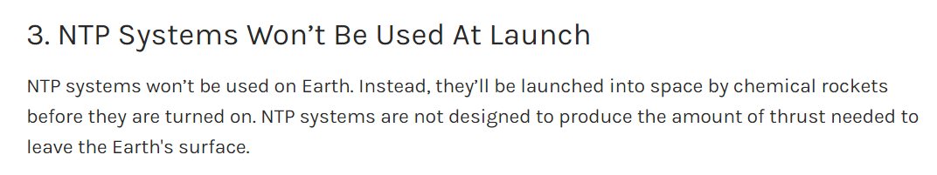

***Can we produce enough thrust by using different heat transfer design considerations?***

One of the current major disadvantages is that of using chemical rocket first to launch the NTP system, which effectively doesn’t decrease the cost of launching the rocket.

Formulating the simulations’ objective – To model the heat interactions, entropy changes in the Nuclear Thermal Propulsion system which includes the below mentioned components and choose the best possible design which allows for maximum efficiency(Both in terms of size and cost) and thrust.

Main components involved are –

1. Heat exchanger
2. Pump
3. Compressor
4. Stirling engine
5. Mixer and Nozzle - entropy considerations
6. Different fuels – Hydrogen, Nitrogen, Oxygen
7. Radiation shields

References - <https://www.popularmechanics.com/space/rockets/a39970172/the-pentagons-nuclear-thermal-rocket-is-getting-serious/>

<https://www.bigrentz.com/blog/air-compressor-types>

<https://www.digitaltrends.com/web/generating-electricity-on-mars/>

**Modeling Topic 2 -**

To design, model and simulate CHP –

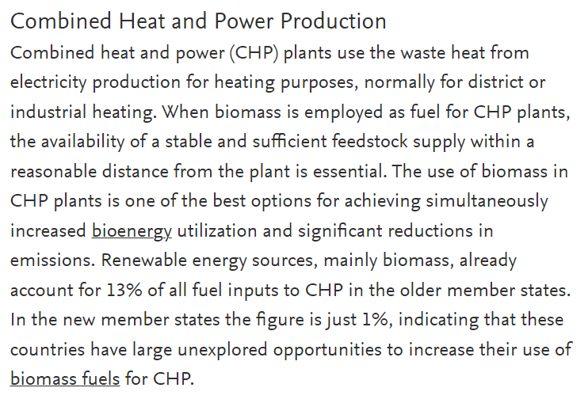

Design process considerations –

1. The size (volume occupation) and mass
2. Impact on using different Fuels
3. Cost vs performance vs efficiency
4. Closed loop process or open loop

Mind Model –

Questions –

1. Can you please upload some links and examples of Models and simulations?